

Feedba
Ashlands CofE Primary School Feedback and Marking Policy Reviewed July 2025 by SLT





Early Years – mostly verbal feedback. Children will begin to self evaluate work in the Summer Term by using a face in order to be ready for Year One.

Marking Expectation;
Marking will be ‘Light touch’. Marking should refer to the specific learning objective of the lesson. Where appropriate, children will self-assess against the objective either verbally or using the drawn face system if recorded.
Drawn faces will be used to show:
- Smiley face – met learning objective
- Straight face – not secure, needs more practice
- Wobbly face – you need more support, let us help

In Maths and Guided Reading where recorded, teachers will use the drawn face to assess alongside the children’s own assessment. .
In writing, children will self-assess to the main objective. Teachers will assess short-burst tasks focused on one main objective, alongside key developmental features. This should be appropriate to the age / stage of the child. For example - Year 1 – mark full stops in text – circle where missing or input for some. Year 5 – next steps show full stop.
This approach helps pupils recognise writing features and ensures daily reinforcement of punctuation and spelling. This will culminate in drawn face assessment.

Science, History, Geography, RE, French – to be self-assessed by pupils. Any written work to be used for assessment purposes may be further assessed by staff member.

Children should be given time to read and respond to any marking symbols or next step bullet point in order that the feedback provided has maximum impact on learning.

Next Steps:
If appropriate, next steps will be
written (drawn as a pair of steps in
orange).
Next Steps will only feature if it:
- provokes future thinking
- it has impact on the child’s learning
- the child can respond to it
- the child can read it
In English, these will be used more frequently, to highlight the next steps in writing. This may be marked as steps against the toolkit or lesson objective. In maths, next steps will be less frequent as feedback is more immediate and oral. Next Steps learning is used to inform future planning.
Where possible all children will receive oral feedback by marking their work with the teacher or teaching assistant. Children will be given the chance to respond by editing their work in purple pen.
Rewards (linked to Behaviour Policy): House points and Green Leaves can be awarded for good work/effort. An outstanding piece of learning may also be shown to the Headteacher/SLT and a Proud Wall certificate may be given.

Self-assessment: In every lesson, children are encouraged to self-assess against the specific ‘I can / know...’ objective using our face face evidence (linked to light touch marking).

Editing: Before being formally marked by the teacher, children
are encouraged to edit their own work using purple pens. Errors should be neatly crossed through. Purple Pens will also be used for editing following formal marking.
Sufficient time and opportunity will be allowed for children to improve their own work, in response to feedback as we believe this is vital for pupils to learn and make progress in their learning. This is a more common practice in KS2.

Peer-assessment (prior to teacher assessment): It can be helpful for children to assess the work of others in the class, this feedback may be verbal or written. Dialogue about learning is an important skill that we seek to develop throughout the school. The child reviewer
should initial any comments.

We strongly believe that marking should:
- Have a purpose and have an impact on the child’s learning
- Provide meaningful feedback to the child
- Highlight areas for development, improvement or correction thereby enabling the child to identify clear ‘next steps’
- Record a child’s progress related to learning objectives
- Inform future planning of lessons
- Be relevant and necessary
- Make the invisible visible: show evidence of action, making excellent practice visible
- Where possible, be verbal - verbal feedback (individual, group based, or to the whole class) will be given to children during the lesson as this has greater impact on the child’s understanding of how they can improve.
At Ashlands, every teacher understands the importance of feedback and marking and that they are important to the progress of our pupils. We want happy, successful and aspirational learners, who show respect for their own and others’ work and are willing to take a risk and KNOW how to improve! The purpose of marking written work is to assess the depth of learning that has taken place and to identify misconceptions to inform future teaching.
Agreed marking colours:
Green ink for ‘This is great’
Orange for ‘Look and Check’
Children edit their work in Purple Pen

Marking Codes:
G (1:4) = Guided learning, this work is completed in an adult lead group. Ratio indicates number of children to adult.
D = Discussion or further teaching that has taken place, this could include children self-marking their work using purple pen at the same time.
H = Individual help given on a particular question.
P = Paired or partner learning / work.

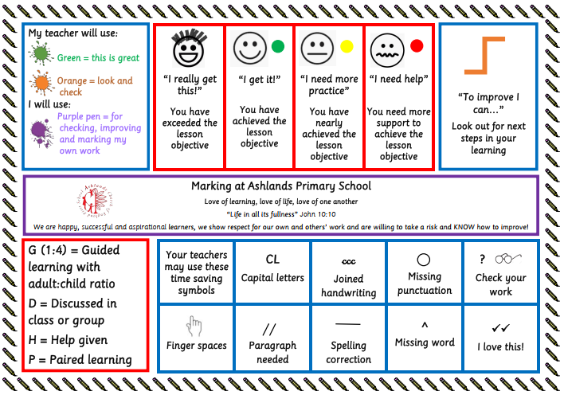
Ashlands Feedback and Marking Policy Appendix

